Name: Jagtap Shivraj Vaibhav
Roll no: EN24107060
Class: SY- AI&DS – A
Subject : Robotics and Automation (MDM)
______________________________________________________________________________________________

Experiment NO-1

Title:-
Study on Selection of Actuators and related hardware such as Dc motor, Servo motor, Stepper Motor, Motor drives based on application.

1. Introduction to Automation Studio
Automation Studio is a simulation software used for designing and testing hydraulic, pneumatic, electrical, and control systems.
It helps students and engineers to:
- Design circuits using standard industrial components.
- Simulate real-time working of systems.
- Analyze pressure, flow, and motion.
- Avoid physical damage and cost during testing.
It is widely used in robotics, automation, and industrial training.
2. Hydraulic Circuit and Pneumatic Circuit

Hydraulic Circuit
A hydraulic circuit uses pressurized liquid (oil) to transmit power. It is used where high force and heavy load are required.
Examples: Press machines, lifts, cranes, industrial robots.

Pneumatic Circuit
A pneumatic circuit uses compressed air to transmit power. It is used where fast motion and clean operation are required.
Examples: Pick and place robots, packaging machines.

3. Simulation of Hydraulic Circuit using 4/3 Directional Control Valve
Aim:
To simulate a hydraulic circuit for controlling a double-acting cylinder using a 4/3 directional control valve in Automation Studio.

Components Used in the Circuit
1.Hydraulic Reservoir (Tank)
2.Hydraulic Pump
3.Electric Motor
4.Pressure Relief Valve
5.4/3 Directional Control Valve (DCV)
6.Double Acting Cylinder
7.Pressure Gauge
8.Pipes and Connectors

Circuit Design Procedure in Automation Studio
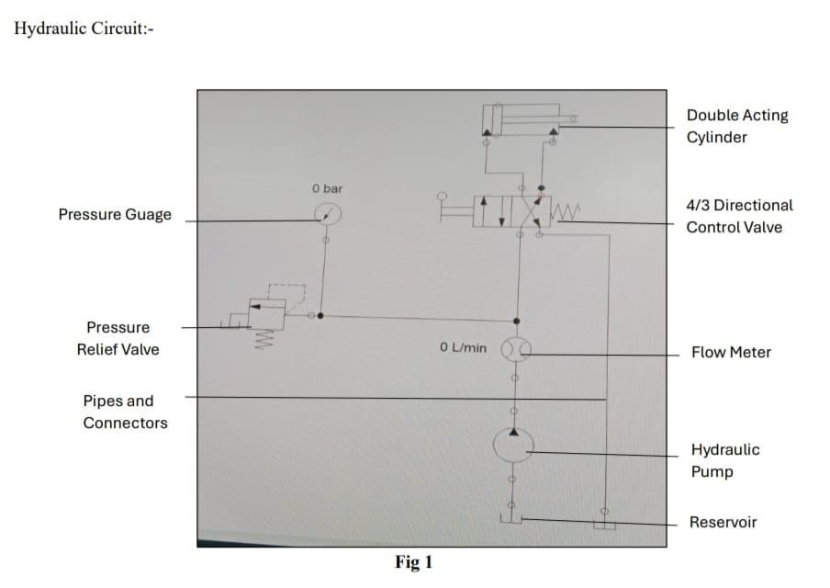
1.Open Automation Studio.
2.Select Hydraulic Library.
3.Place a Reservoir on the workspace.
4.Connect a Pump driven by an electric motor.
5.Add a Pressure Relief Valve to protect the system.
6.Insert a 4/3 Directional Control Valve.
7.Connect the valve to a Double Acting Cylinder.
8.Connect all return lines to the tank.
9.Start simulation and operate the DCV.
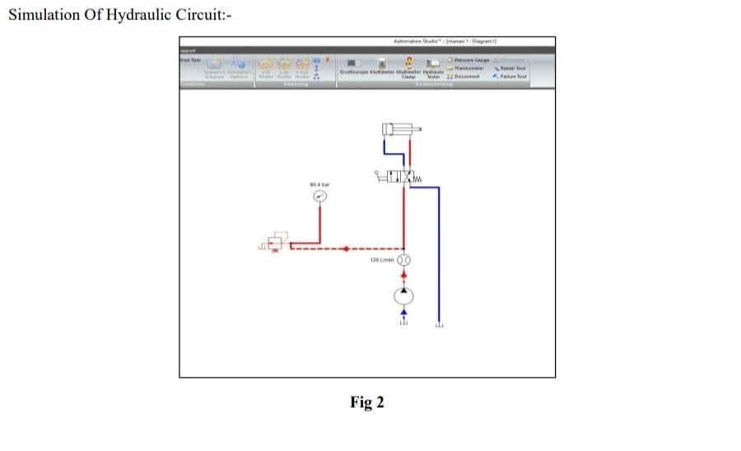

Working / Final Circuit Description
- When the DCV is shifted to the left position, oil flows to the piston side → Cylinder extends.
- When shifted to the right position, oil flows to the rod side → Cylinder retracts.
- In the center position, oil returns to tank (neutral condition).
Thus, the 4/3 valve controls forward and backward motion of the cylinder.

Applications
- Hydraulic press machines.
- Industrial robotic arms.
- Lifting systems.
- Injection molding machines.

4. Simulation of Pneumatic Circuit using 4/3 Directional Control Valve
Aim:
To simulate a pneumatic circuit for controlling a double-acting cylinder using a 4/3 directional control valve in Automation Studio.

Components Used in the Circuit
1.Air Compressor
2.Air Receiver Tank
3.FRL Unit (Filter, Regulator, Lubricator)
4.4/3 Directional Control Valve
5.Double Acting Cylinder
6.Silencer
7.Pipes and Connectors

Circuit Design Procedure in Automation Studio
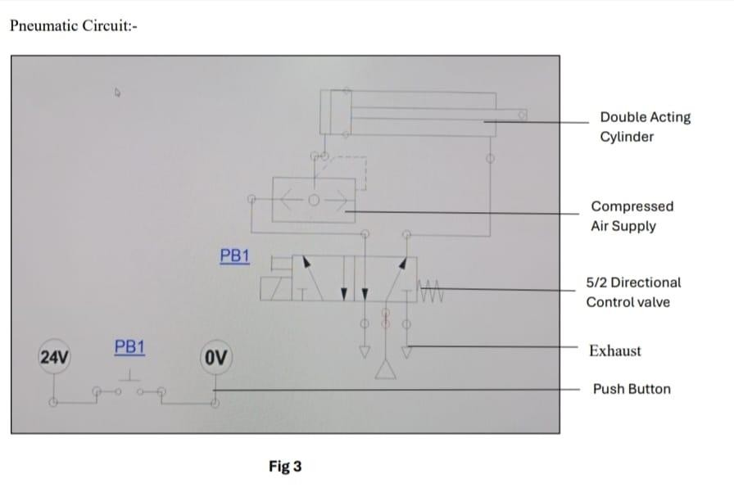
1.2Open Automation Studio.
2.Select Pneumatic Library.
3.Place an Air Compressor.
4.Add an FRL Unit to clean and regulate air.
5.Insert a 4/3 Directional Control Valve.
6.Connect it to a Double Acting Cylinder.
7.Connect exhaust ports to silencers.
8.Run the simulation and operate the DCV.
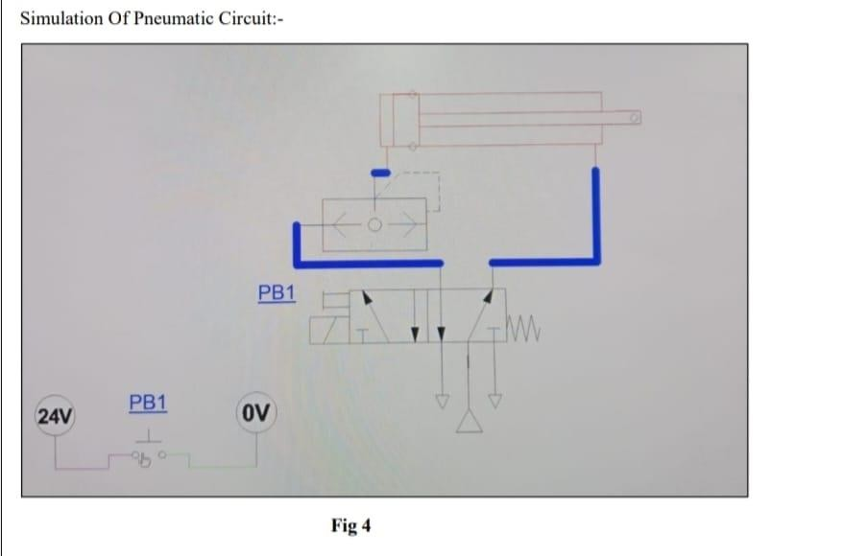

Working / Final Circuit Description
- When DCV is in left position → Compressed air enters piston side → Cylinder extends.
- When DCV is in right position → Air enters rod side → Cylinder retracts.
- In center position → Air supply is blocked or exhausted (depends on valve type).
This controls bidirectional motion using compressed air.

Applications in Robotics and Automation
- Pick and place robotic arms.
- Assembly line automation.
- Clamping and gripping mechanisms.
- Material handling systems.
- Packaging and sorting machines.

Conclusion:
- This experiment provided a clear understanding of how to select appropriate actuators such as DC motors, servo motors, and stepper motors based on different application requirements in robotics and automation. It also helped in studying the working principles of hydraulic and pneumatic systems using a 4/3 directional control valve.
- Through simulation in Automation Studio, we observed how fluid power (hydraulics) is suitable for high-force applications, while pneumatic systems are ideal for fast and clean operations. The use of a double-acting cylinder with a 4/3 DCV demonstrated effective control of bidirectional motion in both systems.
- Overall, the experiment enhanced practical knowledge of actuator selection, circuit design, and system behavior, which is essential for designing efficient and reliable automated and robotic systems.

